1. SELECT DISTINCT airport.airport_name, airport.city

FROM bookings.airports airport, bookings.aircrafts aircraft, bookings.flights flight

WHERE airport.airport_code = flight.departure_airport And flight.aircraft_code = aircraft.aircraft_code And

aircraft.range = (Select MAX(air.range) From bookings.aircrafts air)

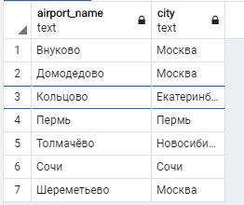

2. SELECT Count(bookin.book_ref) as "Count"

FROM bookings.tickets ticket, bookings.bookings bookin, bookings.ticket_flights t_flight, bookings.flights flight

WHERE bookin.book_ref = ticket.book_ref And ticket.ticket_no = t_flight.ticket_no And t_flight.flight_id = flight.flight_id

And flight.status = 'Cancelled'

Таких бронирований не было

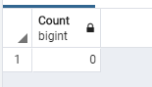

3. SELECT aircraft.model, (CAST(Count(aircraft.model) As float) / CAST((SELECT Count(aircraft.model) From bookings.aircrafts aircraft, bookings.flights flight

Where aircraft.aircraft_code = flight.aircraft_code) As float)) * 100 as "%"

FROM bookings.aircrafts aircraft, bookings.flights flight

WHERE aircraft.aircraft_code = flight.aircraft_code

Group by aircraft.model

Наибольший процент перелетов совершают самолеты моделей: "Bombardier CRJ-200", "Sukhoi SuperJet-100", "Cessna 208 Caravan"

Наибольший из всех: "Cessna 208 Caravan"

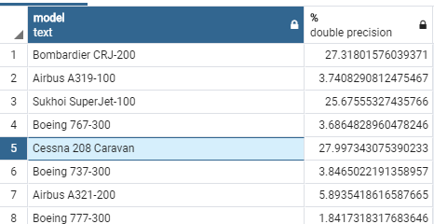

4. SELECT Distinct air.city

FROM bookings.airports air, bookings.flights flight, bookings.ticket_flights t_flight

Where air.airport_code = flight.arrival_airport And flight.flight_id = t_flight.flight_id

And t_flight.fare_conditions = 'Business' And

t_flight.amount < (Select MAX(t_flight.amount) From bookings.ticket_flights t_flight WHERE t_flight.fare_conditions = 'Economy')

Order by air.city

Такие города были

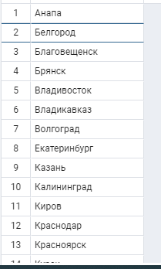

5. SELECT MAX(flight.actual_departure - flight.scheduled_departure) as "Задержка"

FROM bookings.flights flight

WHERE flight.actual_departure IS NOT NULL And flight.scheduled_departure IS NOT NULL

Максимальная задержка:

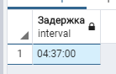

6. SELECT ticket.ticket_no

FROM bookings.ticket_flights t_flight, bookings.tickets ticket, bookings.flights flight, bookings.airports airport

WHERE ticket.ticket_no = t_flight.ticket_no And t_flight.flight_id = flight.flight_id

And flight.arrival_airport = airport.airport_code And (flight.actual_departure - flight.scheduled_departure) < '24:00:00'

Group by ticket.ticket_no

HAVING Count(t_flight.flight_id) > 1

Order by ticket.ticket_no

